**Setting up Application Environment**

**Create Send Grid Account**

|  |  |
| --- | --- |
| Date | 5 November 2022 |
| Team ID | PNT2022TMID47261 |
| Project Name | Plasma Donor Application |
| Maximum Marks |  |

**Step 1**: Navigate to <https://sendgrid.com>

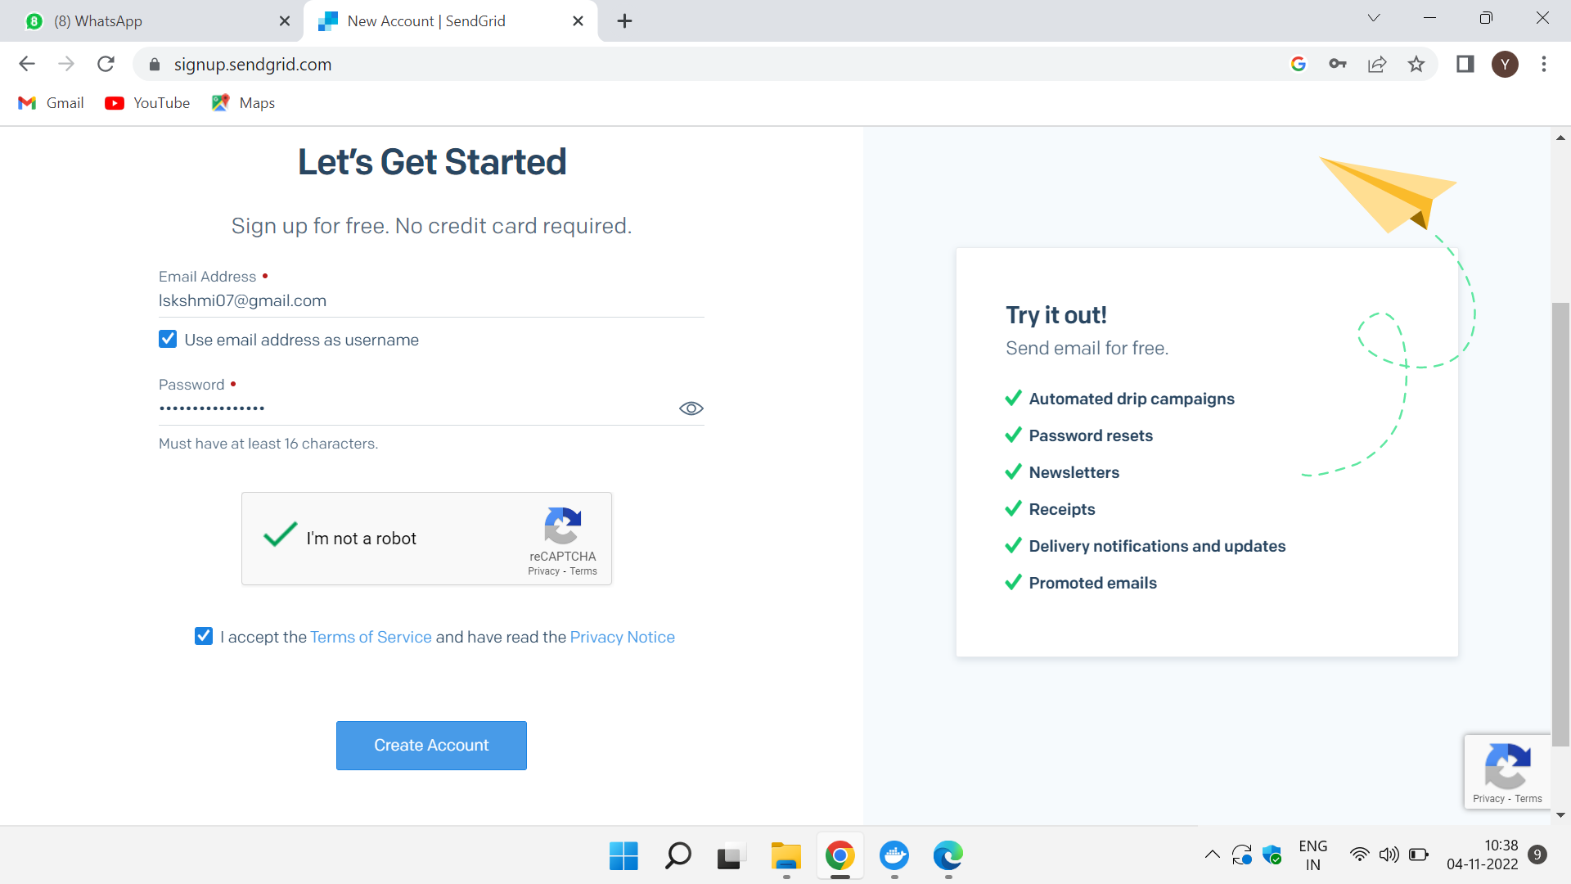

**Step 2:** Click on “ Start for free” and register yourselves by entering required details and click on create account.

**Step 3:** Further fill all required details in next page and click on get started.

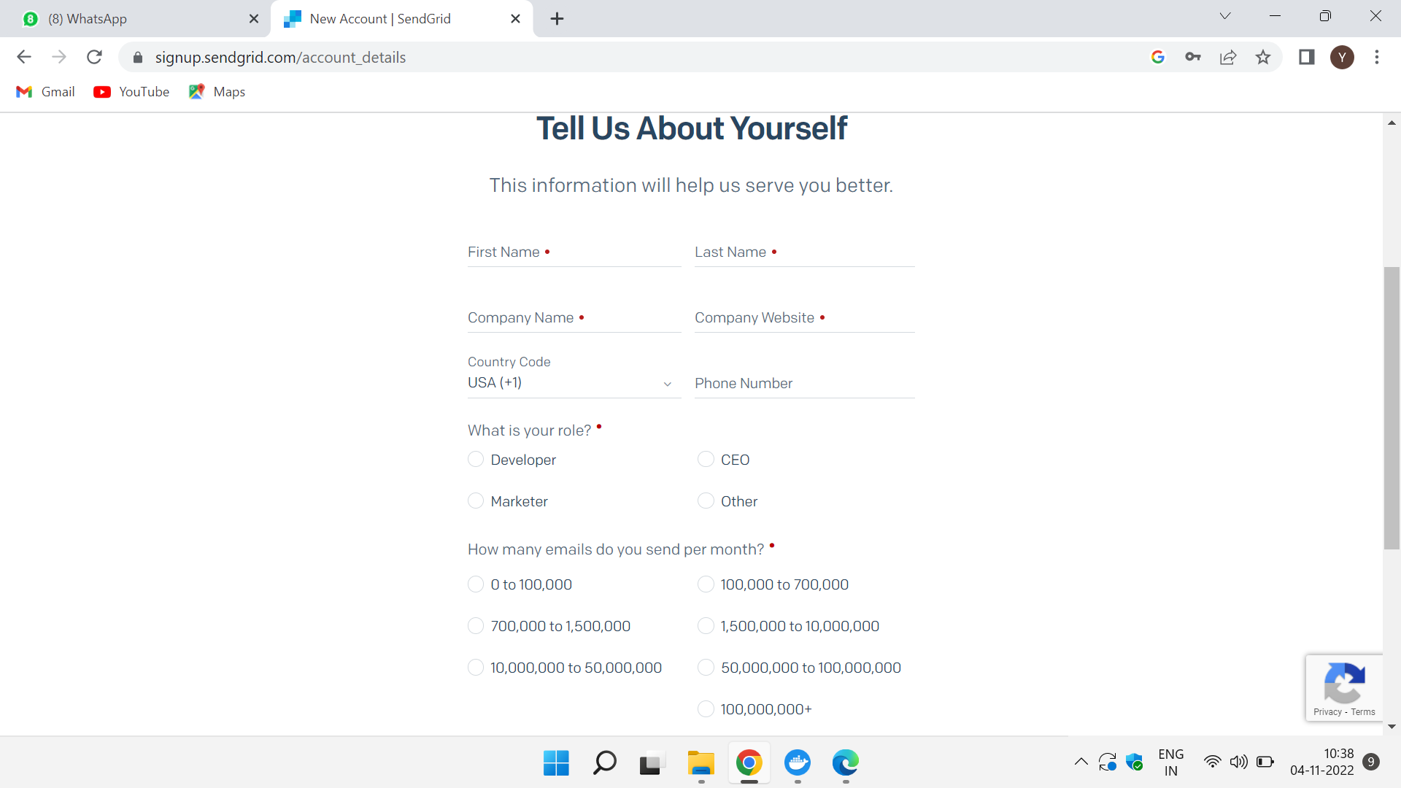

**Step 4:** Account and got access to dashboard That’ s it you have created your Send Grid.

**Output:** Send Grid account created successfully.